Consider a storage disk with 4 platters (numbered as 0,1,2 and 3), 200 cylinders (numbered as 0,1,…,199), and 256 sectors per track (numbered as 0,1,…255). The following 6 disk requests of the form [sector number, cylinder number, platter number] are received by the disk controller at the same time:  
  
[120,72,2],[180,134,1],[60,20,0],[212,86,3],[56,116,2],[118,16,1]  
  
Currently head is positioned at sector number 100 of cylinder 80, and is moving towards higher cylinder numbers. The average power dissipation in moving the head over 100 cylinders is 20 milliwatts and for reversing the direction of the head movement once is 15 milliwatts. Power dissipation associated with rotational latency and switching of head between different platters is negligible.  
  
The total power consumption in milliwatts to satisfy all of the above disk requests using the Shortest Seek Time First disk scheduling algorithm is _____

*Shortest Seek Time First (SSTF), selects the request with minimum to seek time first from the current head position.*

In the given question disk requests are given in the form of ⟨sectorNo, cylinderNo, platterNo⟩.

Cylinder Queue :72,134,20,86,116,16

Head starts at :80

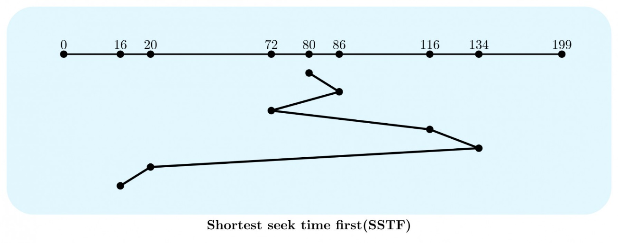

Total head movements in SSTF =(86−80)+(86−72)+(134−72)+(134−16)=200

* Power dissipated in moving 100 cylinder =20mW
* Power dissipated by 200 movements (say P1)=0.2∗200=40mW
* Power dissipated in reversing head direction once =15mW
* Number of times head changes its direction =3
* Power dissipated in reversing head direction (say P2)=3∗15=45mW

Total Power Consumption is P1+P2=85mW

Hence, 85mW is the correct answer.

Suppose the following disk request sequence (track numbers) for a disk with 100 tracks is given: 45, 20, 90, 10, 50, 60, 80, 25, 70. Assume that the initial position of the R/W head is on track 50. The additional distance that will be traversed by the R/W head when the Shortest Seek Time First (SSTF) algorithm is used compared to the SCAN (Elevator) algorithm (assuming that SCAN algorithm moves towards 100 when it starts execution) is _________ tracks